TIME SERIES FORECASTING PROJECT

BUSINESS REPORT

SULOCHANA

**Problem:**

For this particular assignment, the data of different types of wine sales in the 20th century is to be analysed. Both of these data are from the same company but of different wines. As an analyst in the ABC Estate Wines, you are tasked to analyse and forecast Wine Sales in the 20th century.

Data set for the Problem:  [Rose.csv](https://olympus.mygreatlearning.com/courses/78183/files/7099988/download?verifier=L8PWXNvPBPVDVD1ai3AingNLr5H1lo60YYjW3Vms&wrap=1)

1. **Read the data as an appropriate Time Series data and plot the data.**

**Data head:**

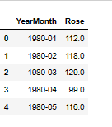

**Data tail:**

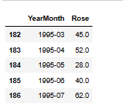

**Data shape:**

(187, 2)

**There are total 187 entries are present in the dataset.**

**The dataset contain two columns, where the first columns contain mentioned about the month and year and second column shows sales.**

**After extracting the date from the data .Here, new column added with the name of date.**

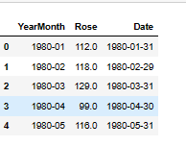

**Data info**

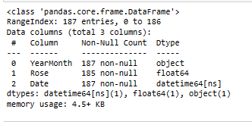

**Now above output shows three columns. Here we can remove yearmonth column after adding date column because both have same information.**

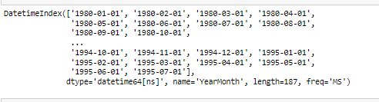

**The above output shows index of the dataset. The dataset started from the January 1980 going till July 1995.**

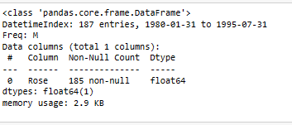

**Above output shows date column is converted into index. Now we have single column Rose.**

**Line Plot for basic understanding of the data:**

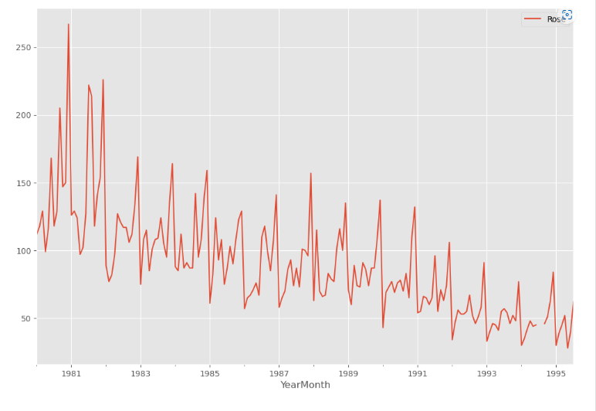

**As we can observe from the above plot the sales for Rose wine shows slightly upward trend. There is a seasonality is visible in this dataset. So, we will explore trend and seasonality during decomposition, where we will be able to view a much detailed on these two factors. We can say this is a multiplicative decomposition.**

1. **Perform appropriate Exploratory Data Analysis to understand the data and also perform decomposition.**

**Descriptive statistics:**

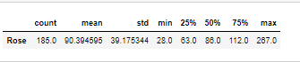

* **Based on above output we can say the total observations are 187**
* **The mean of the sparkling wine sale is** 90.394595**.**
* **The minimum value of sale is** 28.0 **and the maximum value is 267.0**
* **There is a large difference between minimum and maximum sale.**

**Null value checking:**



**As we can see there are 2 null values in this dataset. Here we can treat null values using liner interpolation method to impute null values.**

**Null value treatment:**

**Interpolate using spline method with order 3:**

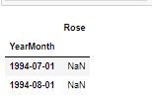



## Mean and Median of Rose wine sale in 20th century

## Mean of the time series:

Rose 90.394595

**The above output is mean of this sale quantity.**

## Median of the time series:

Rose 86.0

**Based on above output, the median of the sale is 86.0.**

## Box plot:

## Box plot of data for each year with year labels

## 

## As we can observe, Rose wine has mostly a downward sale trend.. The highest sale seems to be happening in the 1981 and the lowest in the 1994. The Rose wine sale appears to be going down from the year 1990. There outliers in this data, however as it is a time series we can ignore the outlier data.

## Box plot for each Calendar month across years

## 

## As we can observe monthly box plots, we can see the seasonality and upward trend. The sales are increasing from July month to December. The sale is relatively low in first two quarters, slowly picks up pace during the third quarter and goes on a rise till the end of the year. Monthly sales data shows skewness.

## Month plot of the Time Series

## 

## Month sales years pivot table:

## 

## Month sales years plot:

## 

## As can be observed from the above table and graph, the months of the December seems to be the month that derives the highest sales. The second highest sales of Rose wine sale happened in July and august. We can observe a seasonality element in the graph.

## Conversion of Data to other periodicity (Resampling)

## df1 year

## 

## Rose wine year plot

## 

## Rose wine yearly_mean

## 

## Rose wine yearly mean plot

## 

## As can be observed from the above summation table and graph, Rose wine annual sales year on year observe a downward sales trend.

## Resample the data to quarterly frequency and calculate the sum for each quarter:

## 

## Quarterly sale plot

## 

## Quarterly sale mean

## 

## Quarterly sale mean plot

## 

## From the above output, we can observe that the quarterly sales show an downward trend for wine sale. Also there is a slight element of seasonality in dataset.

## daily sale sum:

## 

## Daily sale plot

## 

### Here we don’t need to observe daily data because the frequency of observations of time series in this data is monthly.

## Decade sale

## 

## Decade sale plot:

## 

## As we can observe from the above decade sale graph, it show sale rising from 1980 to 1990 and after that sale started to decreasing.

## Time Series Decomposition:

# Additive Model:

**Decompose time series components using additive model**

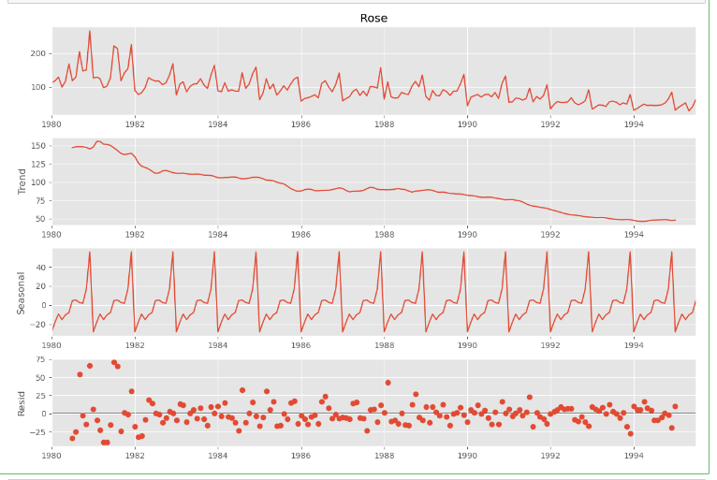

**The first 12 rows of trend component**

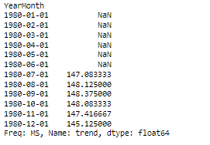

**The last 12 rows of trend component**

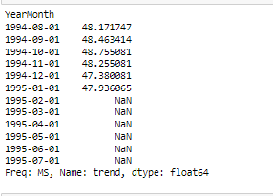

**The first 12 rows of seasonal component:**

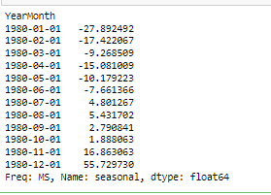

**The last 12 rows of seasonal component:**

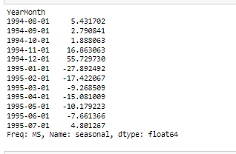

**The min and max seasonal component values**

(-27.892492457469054, 55.72972976475316)

**The first 12 rows of resid values:**

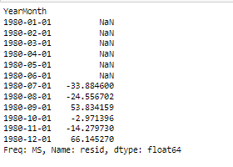

**The last 12 rows of resid values:**

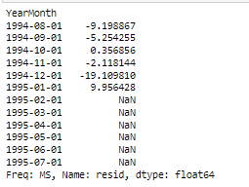

**Seasonal decomposition .residual mean**

-0.08006846794752842

## De-Seasonalized Time Series

## Time series values minus the seasonal component

## 

## Plot the actual time series and the deseasonalized time series in different colors in the same plot

## 

## Multiplicative Model

## 

## The first 12 rows of the trend component

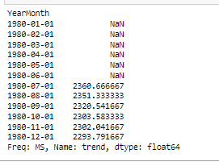

## The last 12 rows of the trend component

## 

## The first 12 rows of the seasonal component

## 

## The law 12 rows of the seasonal component

## 

## The first 12 rows of the residual values:

## 

## The first 12 rows of the residual values:

## 

## Residual component mean

0.9997456359115033

## As we can observe from the above output, we can say that the wine time series are clearly multiplicative in nature and have a seasonal component. Here again we can see downward trend in the dataset. The plots clearly indicate that the wine sales are unstable and not uniform, and they have an apparent seasonality trend. Moreover, the sales variation seems to be in this dataset.

1. **Split the data into training and test. The test data should start in 1991.**

**Here the data spitted into train and test dataset. The train dataset start from the 1980 to 1991 and test data start from the year 1981 to 1995.**

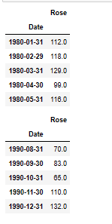

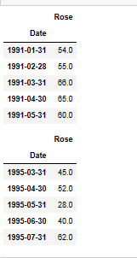

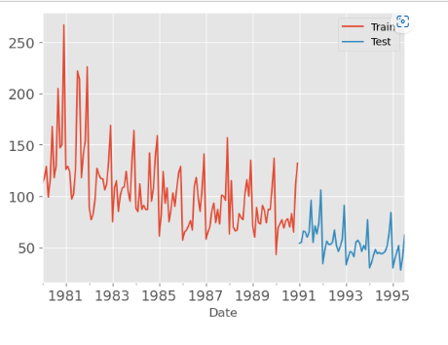

**As we can observe, the size of the train data frame is 132 observations and that of the test data frame is 55 observations.**

1. **Build all the exponential smoothing models on the training data and evaluate the model using RMSE on the test data. Other models such as regression, naive forecast models and simple average models. Should also be built on the training data and check the performance on the test data using RMSE.**

**Now we can build different models to find out which model gives better predictions for future 12 months forecasting.**

**Models**

# Model 1: Linear Regression

# Model 2: Naive Approach: 𝑦̂ 𝑡+1=𝑦𝑡

**Method 3: Simple Average**

**Method 4: Moving Average (MA)**

**Method 5: Simple Exponential Smoothing**

**Method 6: Double Exponential Smoothing (Holt's Model)**

**Method 7: Triple Exponential Smoothing (Holt - winter’s Model)**

# Model 1: Linear Regression

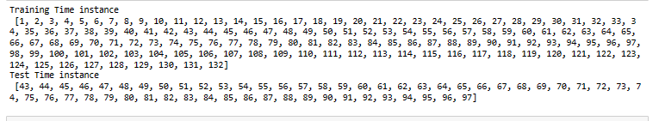

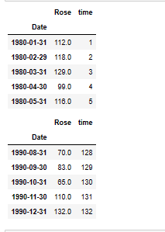

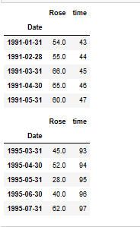

**The above output shows train and test data for the liner regression model.**

**The below output shows the results of model after fit the liner regression model.**

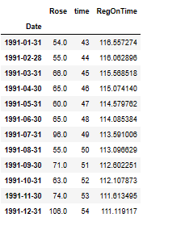

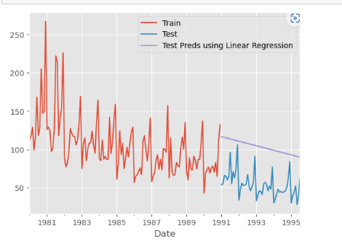

**The regression plots above depict the regression on training set as the red line and that on the test dataset as the blue line. As we can observe from the above plot Rose wine sale shows downward trend.**

**Test Data – RMSE:**

51.48684260153627

# Model 2: Naive Approach:

picking out the last value in train dataset

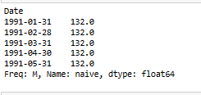

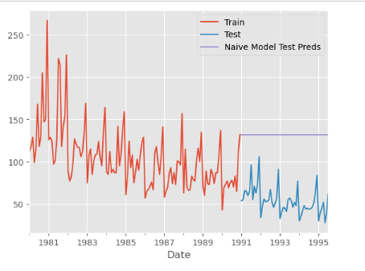

## Model Evaluation:

**Test Data – RMSE**

79.77806619469453

Above outputs are results of after building naïve model on data set. As can be seen from the naïve model performance from the above, we can see it is a worst performance on data. It is not suitable for our data set since the forecasts depends on the previous last observation.

# Method 3: Simple Average

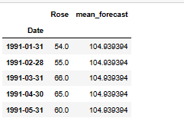

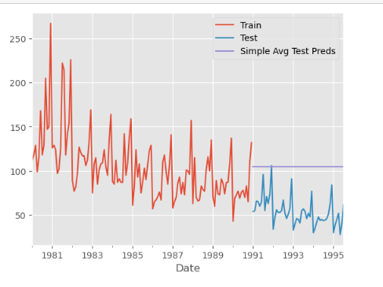

## Model Evaluation:

**Test Data – RMSE:**

53.52155715428721

As can be seen from the simple average model performance on this dataset above, the simple average model has the better performance compared to naïve approach.

# Method 4: Moving Average (MA)

For the moving average model, we are going to calculate rolling means (or moving averages) for different intervals. The best interval can be determined by the maximum accuracy (or the minimum error) over here.

**For Moving Average, we are going to average over the entire data.**

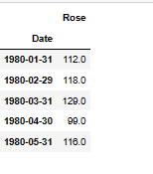

## Trailing moving averages

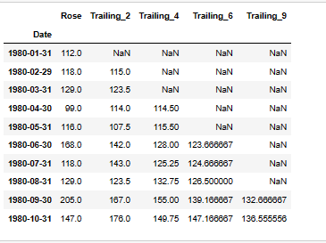

**Plotting on the whole data**

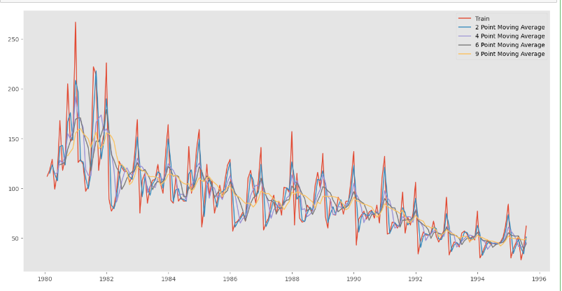

**Creating train and test set:** Here we split the data into train and test and plot this Time Series.

**Plotting on both the Training and Test data**

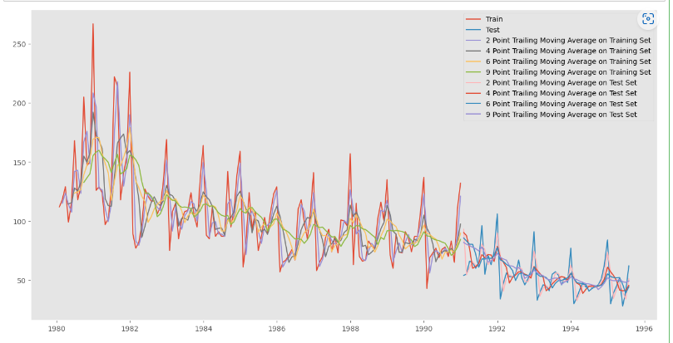

## Model Evaluation:

This only we have done on the test data.

**Test Data - RMSE --> 2 point Trailing MA**

11.53017959780346

**Test Data - RMSE --> 4 point Trailing MA**

14.462329946639356

**Test Data - RMSE --> 6 point Trailing MA**

14.5869157725431

**Test Data - RMSE --> 9 point Trailing MA**

14.740111675183757

* As we can observe from the above plots, all of the trailing average plots show prediction values below the actual train and test datasets, and the 9 point trailing average plot shows the lowest prediction of all the plots.
* The closest prediction to actual data shown by the 2 point trailing moving average model
* This observation is corroborated by the RMSE scores for each of these moving average models.
* As can be seen from the summarized performance of all the models, the 2 point moving average has shown the best performance of all the models run on the Rose wine datasets.

## Before we build the various Exponential smoothing models, let’s plot all the models and compare the Time Series plots.

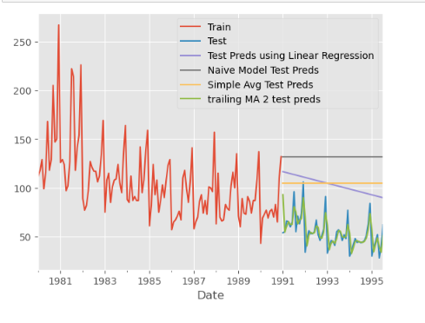

# Method 5: Simple Exponential Smoothing

**Simple exponential smoothing autofit params:**

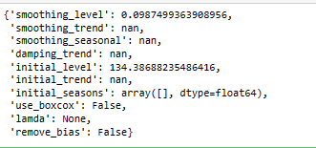

**SES test data head:**

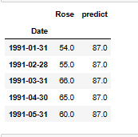

**Plot on SES train, test and predicted data**

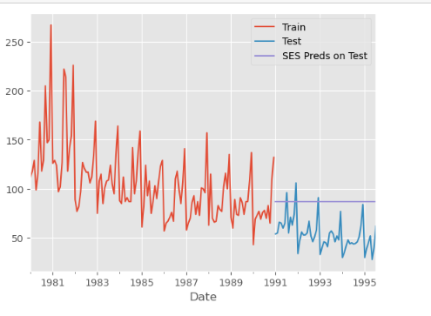

**Model Evaluation for Simple Exponential Smoothing**

**Test Data**

36.763738599307196

**Below is a ouptput after applying different alpha values:**

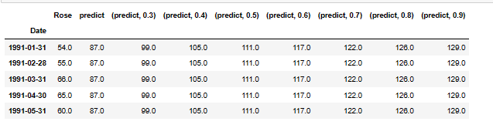

**Model Evaluation**

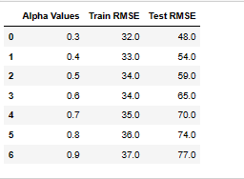

**After sorting the test Rmse values:**

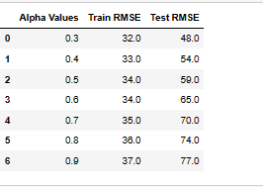

**Plotting on both the Training and Test data:**

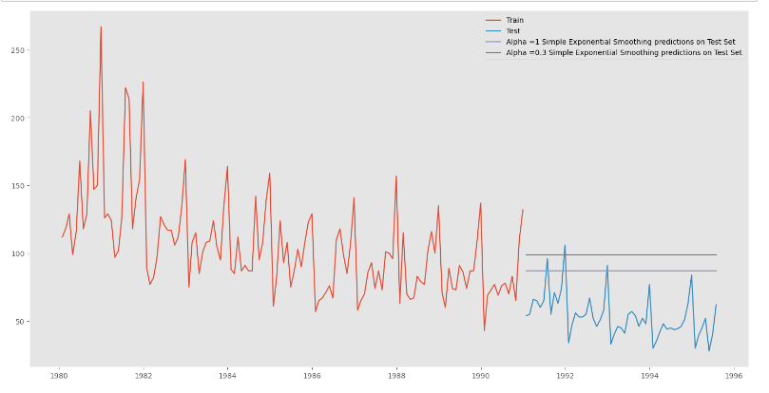

**As we all know that SES model should be used on data which has no element of trend or seasonality. So, on this dataset it did not perform well as compared to the previous models.**

# Method 6: Double Exponential Smoothing (Holt's Model)

Two parameters 𝛼 and 𝛽 are estimated in this model. Level and Trend are accounted for in this model.

**Identifying Optimum Values of 𝛼 & 𝛽**

**Below is a ouptput after applying different alpha and beta values:**

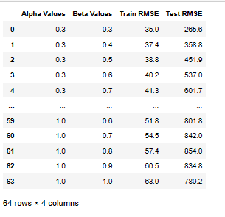

**Following are the results from after running the DES model on this dataset.**

**Sorting test Rmse values for finding best alpha and beta values:**

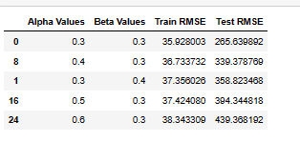

For Alpha = 0.3, Beta = 0.3 Simple Exponential Smoothening Model forecast on the Test data RMSE = 265.639892

**Plotting on both the Training and Test data:**

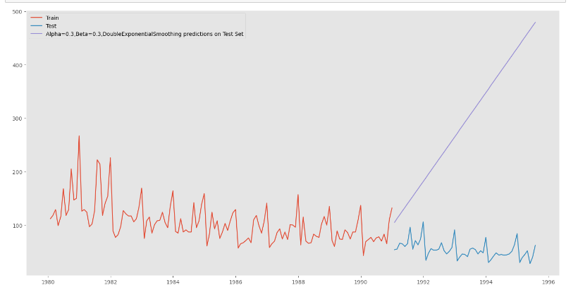

**As we all know that DES model should be used on data which has no seasonality but has level and trends. So this gives a worst performance on dataset as compared to other models.**

# Method 7: Triple Exponential Smoothing (Holt - winter’s Model)

Three parameters , 𝛽 and 𝛾 are estimated in this model. Level, Trend and Seasonality are accounted for in this model.

**TES model autofit params:**

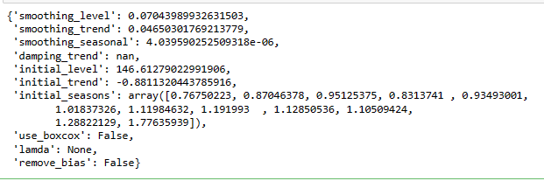

**Prediction on the test data:**

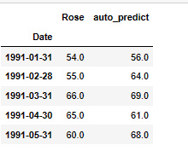

**Plotting on both the Training and Test using autofit:**

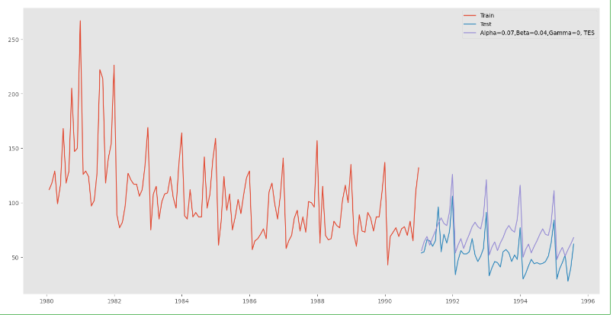

**Test Data Rmse:**

20.424964892944715

**Identifying Optimum Values of , 𝛽 and 𝛾**

**Below is a ouptput after applying different alpha, beta and gama values:**

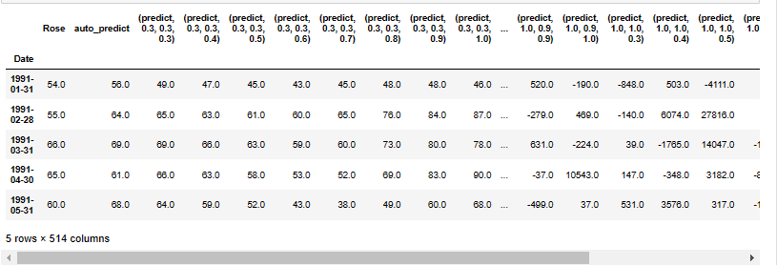

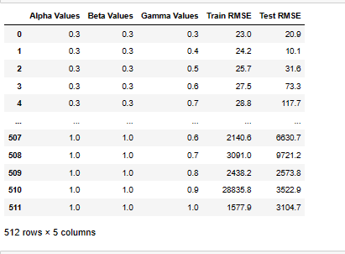

**After sorting the values:**

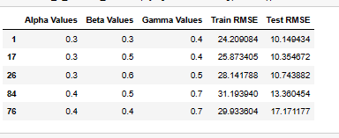

For Alpha = 0.3, Beta = 0.3, gamma = 0.3 triple Exponential Smoothening Model forecast on the Test data RMSE = 10.149434.

**Plotting on both the Training and Test data using brute force alpha, beta and gamma determination:**

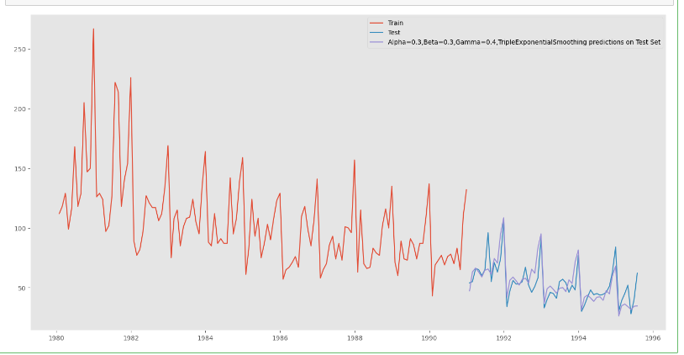

**Plotting on both the Training and Test data and comparing the 3 exponential models:**

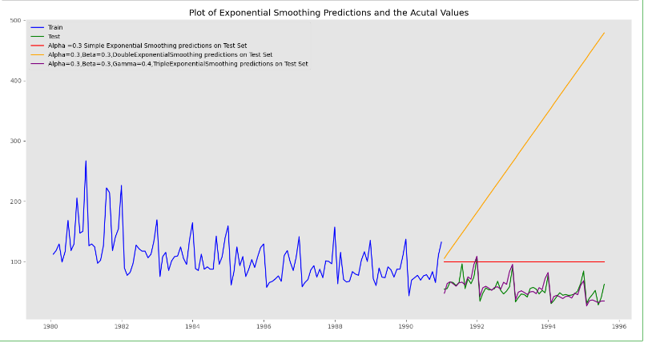

For this data, we had both trend and seasonality so by definition Triple Exponential Smoothing is supposed to work better than the Simple Exponential Smoothing as well as the Double Exponential Smoothing.

We see that the best model is the Triple Exponential Smoothing with multiplicative seasonality with the parameters 𝛼 = 0.3, 𝛽 = 0.3 and 𝛾 = 0.3.

1. **Check for the stationarity of the data on which the model is being built on using appropriate statistical tests and also mention the hypothesis for the statistical test. If the data is found to be non-stationary, take appropriate steps to make it stationary. Check the new data for stationarity and comment. Note: Stationarity should be checked at alpha = 0.05.**

## Check for stationarity of the whole Time Series data.

**Augmented dicky fuller test is used on this data for checking for the stationarity of the data.**

**Test for stationarity of the series - Dicky Fuller test::**

**P value**

0.344736753650672

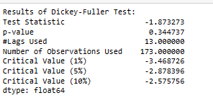

We see that at 5% significance level the Time Series is non-stationary as at high p-value we are unable to reject the null hypothesis.

**Let us take a difference of order 1 and check whether the Time Series is stationary or not.**

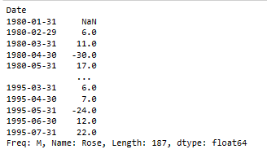

**After differencing the data p value:**

1.8216039932463435e-12

We see that at 𝛼 = 0.05 the Time Series is indeed stationary as the p-value is lower than 0.05 and hence we can reject the null hypothesis which says that the time series is not stationary. So differentiation by 1 makes the time series stationary.

1. **Build an automated version of the ARIMA/SARIMA model in which the parameters are selected using the lowest Akaike Information Criteria (AIC) on the training data and evaluate this model on the test data using RMSE.**

## Autocorrelation & Partial Autocorrelation function

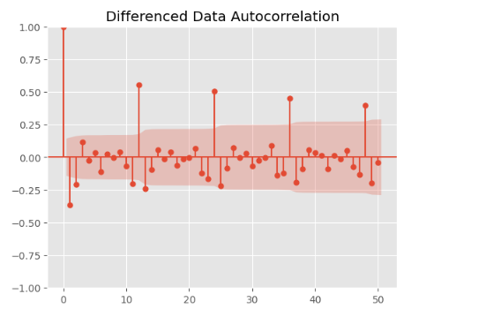

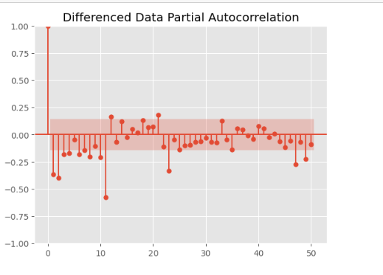

From the above plots, we can say that there seems to be seasonality in the data as there are significant correlations at multiples of 6 and 12 lags.

## Check for stationarity of the Training Data Time Series.

**After performing augmented dicky fuller test on the train data this is the P value**

0.2194756412907245

**We see that the series is not stationary at 𝛼 = 0.05.**

**After differencing the data p value:**

7.061943750943291e-09

After difference of order 1 we see that at 𝛼 = 0.05 the Time Series is indeed stationary as the p-value is lower than 0.05 and hence we can reject the null hypothesis which says that the time series is not stationary. So differentiation by 1 makes the time series stationary.

## Automated version of an ARIMA model: Based on lowest Akaike Information Criteria (AIC).

The data has some seasonality so ideally we should build a SARIMA model. But here we are building an ARIMA model both automatically and manually, by looking at the minimum AIC criterion and manually, by looking at the ACF and the PACF plots.

**ARIMA MODEL:**

**Following are the results of ARIMA model on data:**

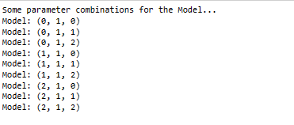

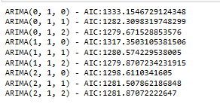

**ARIMA_AIC**

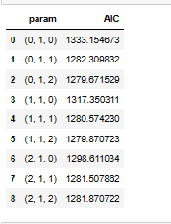

**Sort the above AIC values in the ascending order to get the parameters for the minimum AIC value:**

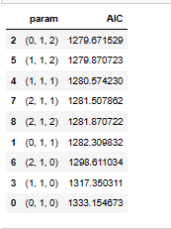

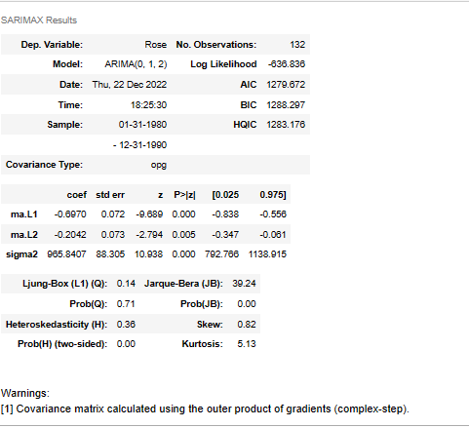

**Predict on the Test Set & Evaluation - Auto Arima Model**

**Predicted auto ARIMA head:**

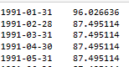

**Predicted auto ARIMA [0] contains the predictions (mean values):**

**RMSE of autoarima**

45.0823106733865

The lowest AIC of sparkling data is 45.082311for p,d,q values of 0,1,2 respectively.

## Automated version of a SARIMA model -Parameter Selection with lowest Akaike Information Criteria (AIC).

Let us look at the ACF plot once more to understand the seasonal parameters PDQ for the SARIMA model.

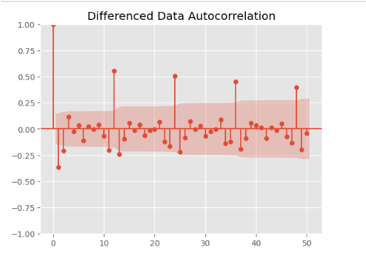

We see that there can be a seasonality of 6 and 12. We will run our auto SARIMA models by setting seasonality both as 6 and 12.

## Auto SARIMA model - With Seasonality as 6

**The following are results of SARIMA model on sparkling data.**

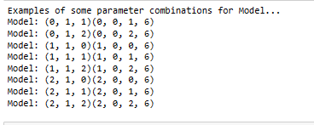

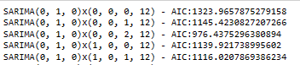

**Sort the above AIC values in the ascending order to get the parameters for the minimum AIC value:**

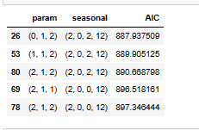

**build a SARIMA model using the pdq and PDQ values identified above. Following results is after run the model on data.**

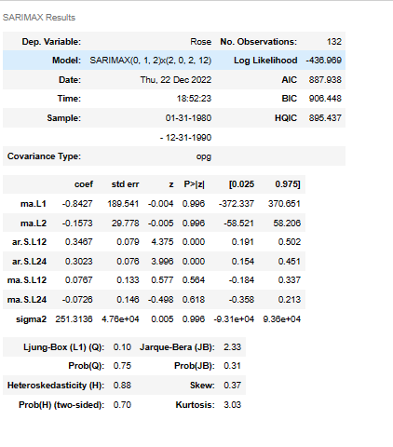

**results_auto_SARIMA_12.plot_diagnostics()**

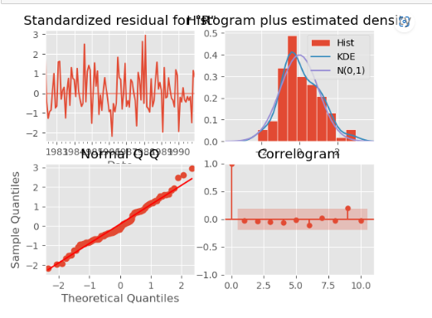

## Predict on the Test Set & Evaluation

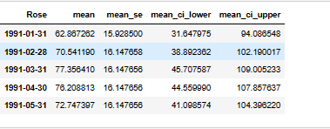

**Rmse of auto SARIMA as 6 month seasonality:**

26.209980751250267

The lowest AIC of SARIMA model on this data is 26.209981for P, D, Q values of 1, 1, 2 respectively.

**Setting the seasonality as 12 for the second iteration of the auto SARIMA model.**

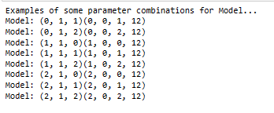

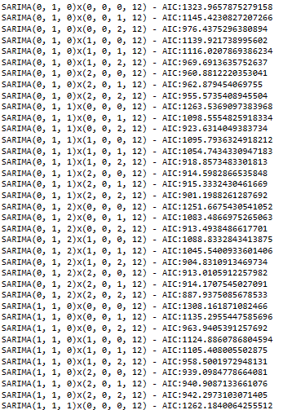

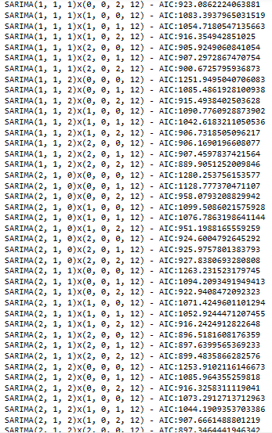

**Sort the above AIC values in the ascending order to get the parameters for the minimum AIC value:**

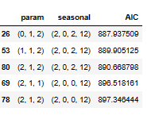

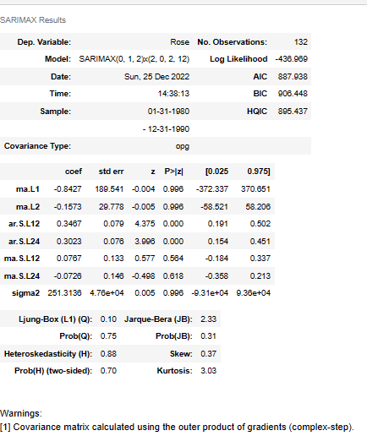

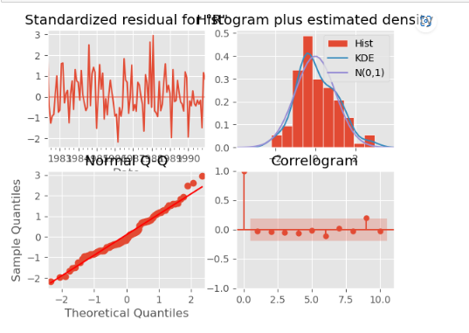

## Predict on the Test Set & Evaluation:

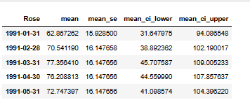

**Rmse auto sarima as 12 month seasonality:**

26.99203704228916

As can be observed, the lowest AIC of SARIMA model on sparkling data is 26.992037for P, D, Q values of 0, 1, 2 respectively.

1. **Build ARIMA/SARIMA models based on the cut-off points of ACF and PACF on the training data and evaluate this model on the test data using RMSE.**

## Manual ARIMA model - Using ACF & PACF plots

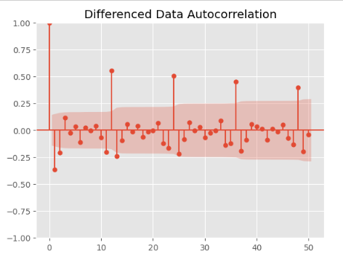

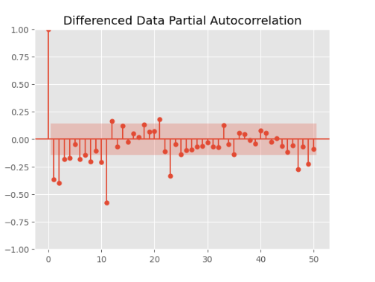

#### Here, we have taken alpha=0.05.

The Auto-Regressive parameter in an ARIMA model is 'p' which comes from the significant lag before which the PACF plot cuts-off to 4. The Moving-Average parameter in an ARIMA model is 'q' which comes from the significant lag before the ACF plot cuts-off to 2. By looking at the above plots, we can say that both the PACF and ACF plot cuts-off at lag 4 and 2. So,our pdq values are 4,1,2.

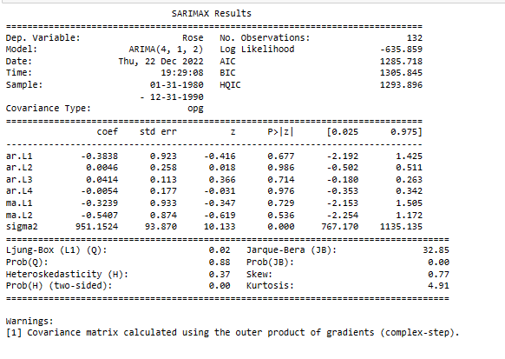

**Predict on the Test Set & Evaluation**

**RMSE manual ARIMA:**

37.09983854487632

## Manual SARIMA model setting the seasonality as 6- Using ACF & PACF plots

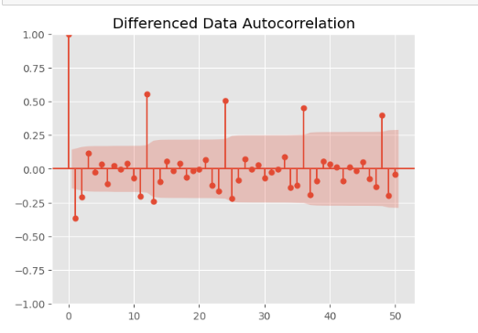

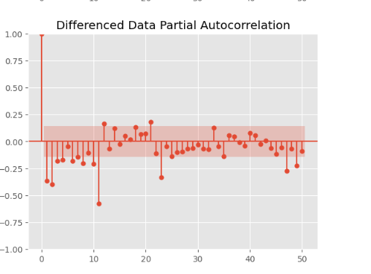

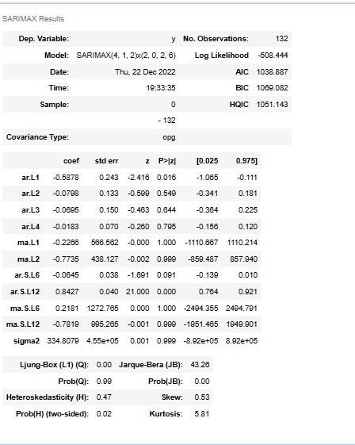

## Predict on the Test Set & Evaluation

**predicted_manual_SARIMA_6.predicted_mean**

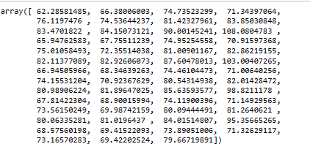

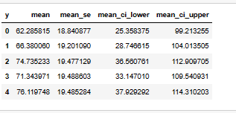

**Rmse manual sarima 6 month**

26.262238303838473

## Manual SARIMA model Setting the seasonality as 12- Using ACF & PACF plots

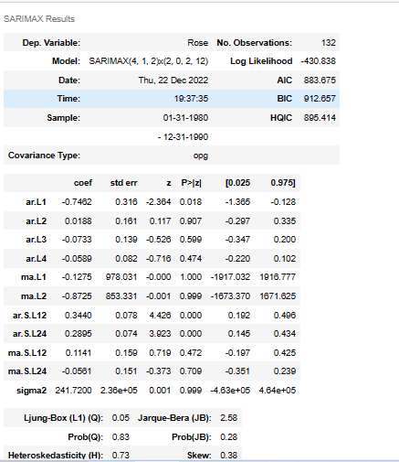

**Predict on the Test Set & Evaluation**

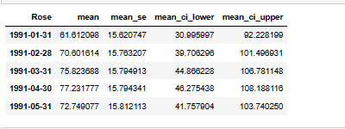

**rmse_manualsarima12**

26.262238303838473

1. **Build a table (create a data frame) with all the models built along with their corresponding parameters and the respective RMSE values on the test data.**

**These are the results after performing different models on this data set.**

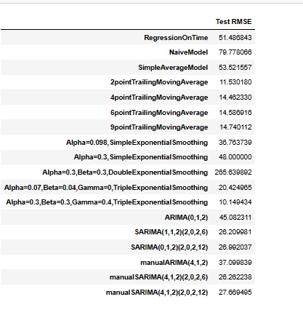

**Sort the above test rmse values in the ascending order to find out the best optimum model on the Rose wine sale for prediction of future 12 month forecasting.**

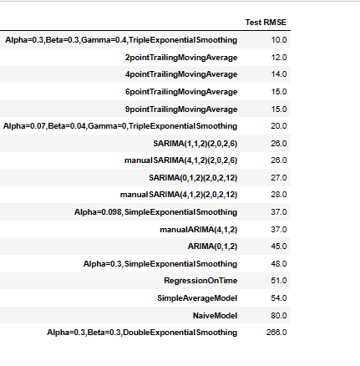

**After building various models on this dataset we can say the triple exponential model is the best optimum model with the parameters α = 0.3, β = 0.3, ϒ = 0.3 as compared to other models. This model gives lowest test rmse value when compared to other models.**

1. **Based on the model-building exercise, build the most optimum model(s) on the complete data and predict 12 months into the future with appropriate confidence intervals/bands.**

## Building the most optimum model on the Full Data.

We see that the best model is the Triple Exponential Smoothing with multiplicative seasonality with the parameters 𝛼 = 0.3, 𝛽 = 0.3 and 𝛾 = 0.4.

**Plotting on both the Training and Test data and comparing the 3 exponential models**

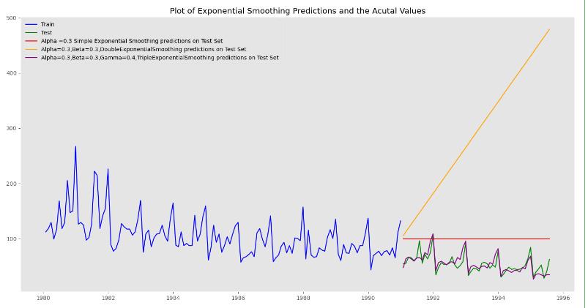

**From above output we can clearly observe the prediction of triple exponential model is replicating the original test data. So, we can say it performs very well.**

**Evaluate the model on the whole and predict 12 months into the future.**

**These following are the results of after run the model on whole data.**

**After predicting 12 months into future the below is the Rmse value.**

21.020471957698383

**Plot the forecast**

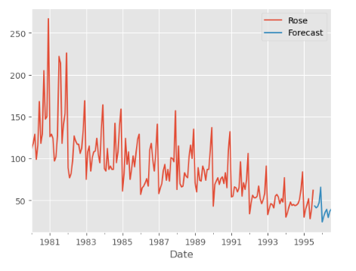

## Prediction Confidence Intervals: Margin of Error

**we have calculated the upper and lower confidence bands at 95% confidence level. Here we are taking the multiplier to be 1.96 since in a normal distribution,95% of values lie within +/- 1.96 sigma of the mean.**

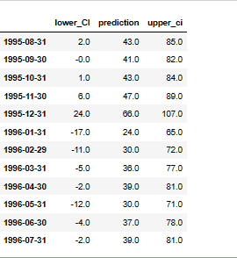

**Plot the forecast along with the confidence band**

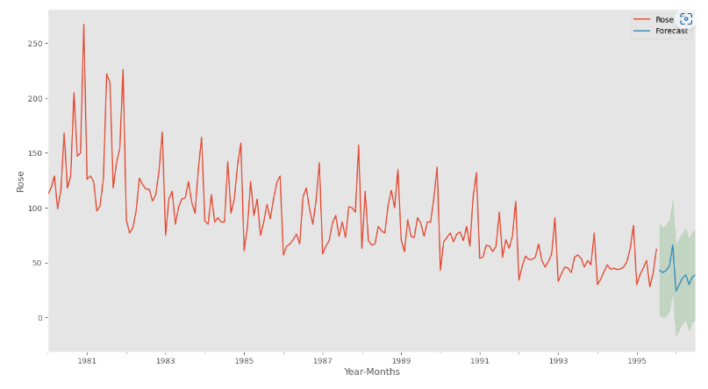

**Finally the above output is the forecasting future 12 months by using triple exponential model with parameters α = 0.3, β = 0.3, ϒ = 0.3.**

**10. Comment on the model thus built and report your findings and suggest the measures that the company should be taking for future sales.**

* Sales in Rose do shows decreasing trend. In the year of 1981 and 1982 sharp rise in sales after it shows slowly decreasing.
* Business study may be done to find why sales are not increasing and what the contributing factors.
* Study can also include seeing which wine product has substituted/ had higher sales in the years of low sales of Rose wine.
* Should investigate in which regions the sale is decreasing and compare the price of this wine with the other similar wine products.
* With promotion and focused effort with micro detailing it may be feasible to increase the sales.
* Sales of Rose wine higher in the end part of the year. This may be due to climatic condition of the geography under study.
* The company should come up with discount offers in the months of January to June as sales are low in this month.
* When we observe as decade plot the sale is gradually increasing from 1980 to 1990 and started to decrease after 1990. This may be due issue of quality or competition of other wine products in the market.
* Hence, the company should focus on quality of the wine and should promote the product with different offers. Once it started to pick up the sale then they can continue normal sale.